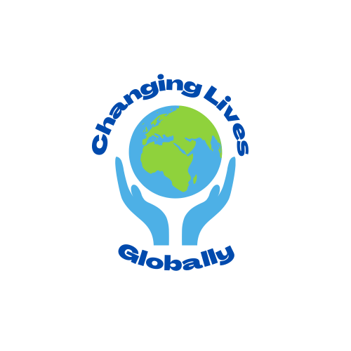

|  |  |
| --- | --- |
| Changing Lives Globally  P.O. Box 902157  Sandy UT 84090  801-548-1473  www.changinglivesglobally.org |  |

Dear Friends, Donors, and Volunteers

My name is Dr. Cesar Diaz and I am the founder and executive director of Changing Lives Globally, a non-profit organization that helps underserved families in need gain access to vital resources. We are getting ready to host our 22nd annual Christmas service project and we need your help! This event is important as it not only provides crucial support to local families in need at this time but also provides an opportunity for our organization to raise funds for other humanitarian goals and spread awareness of our cause across the community.

This annual Christmas service project allows us to provide new toys, clothes, food, and shopping vouchers to hundreds of families living far below the poverty line and/or in situations of distress (refugees, asylum seekers, domestic abuse survivors) each year; hopefully making this holiday season more joyous and less stressful for them. Last year, we were able to provide this special Christmas service to 439 families.

We rely heavily on our volunteers for this project as we use an “adoption” model to carry out these services. Volunteers sign up to adopt a family and provide the necessary items to them personally. If you have participated in this service project previously, we hope you have had a wonderful experience with your adopted family. I can say from personal experience that your efforts and generosity have a deep impact upon these families not only now, but for years to come.

If you would like to adopt a family, please sign up on our website [www.changinglivesglobally.org](http://www.changinglivesglobally.org) and you will receive instructions and information on your family. If you are not able to provide for an entire family but would still like to make a contribution please donate either through our website or venmo: @changinglivesglobally. 100% of these donations will be put towards providing Christmas for families who do not get adopted by volunteers. All donations made to Changing Lives Globally are tax-deductible.

Thank you so much for your support in our mission to help families in need during this holiday season. We are so grateful for your continued support and donations!

With Kind Regards,

Dr. Cesar Diaz MD

Executive Director, Founder

P.S. – The deadline for family adoptions is: _________________